Name: Ravin Godbole
PRN: B25CE1087
Div: CE 2, Batch A
-------------------------------------------------------------------
Experiment name: Electricity Bill Generator
Topic: Scholarship Program

Scholarship Program

Aim: -

The aim of this report is to create a comprehensive program for the process of scholarship application.

Research: -

Around the world, in many countries, people live coming from different backgrounds, from the ultra-rich to those below the poverty line, male or female, different caste etc.
The government of any nation thus has the responsibility of providing good quality education that is affordable for all sections of society irrespective of their gender, income, caste or any other factor.
The system of scholarship thus plays an important role in this.
A scholarship is a form of financial aid awarded to students for further education.
Generally, scholarships are awarded based on a set of criteria such as academic merit, diversity and inclusion, athletic skill, and financial need, research experience or specific professional experience.
Scholarship criteria usually reflect the values and goals of the donor of the award
Scholarships also range in generosity; some cover partial tuition, while others offer a 'full-ride', covering all tuition, accommodation, housing and others.
Historically, scholarships originated as acts of religious and philanthropic charity in medieval Europe before evolving into institutional tools of social mobility and national development.
In recent decades, scholarships have also become vital to public policy.
They are increasingly used by governments and organizations to promote educational equity, economic development, and poverty alleviation international frameworks such as the United Nations Sustainable Development Goal 4 note the key role of scholarships in expanding educational access for disadvantaged learners to meet national and global development goals.
At the same time, rising enrollment and reduced public funding has increased reliance on donor-supported scholarships and cost-sharing models, which further position scholarships as essential mechanisms in offsetting the burden of educational expenses.

References: -

1. en.wikipedia.org
2. scholarship.gov.in
3. upgrad.com

Analysis: -

There exist many types of scholarships.
The types of scholarships are as follows: -
1. Merit-based: These scholarships are based upon the academic, artistic, athletic or other abilities of the student. The requirements vary based upon the providers of the scholarship.
2. Group-specific: These are scholarships exclusive to certain protected groups based on gender, race, medical history, religion etc.
3. Career-specific: These are scholarships that are awarded by government and educational institutions to students specializing in a particular area/field of study.
4. College-specific: These scholarships are offered by colleges and universities to highly skilled applicants and these are given based on personal achievement.
5. Athletic: These scholarships are awarded to students having exceptional skill in sports.

Ideate: -

How to get a scholarship: -
1. Research Scholarship Opportunities: Use websites such as Fastweb and the National Portal of India to filter scholarships by various criteria like GPA, field of study etc. Check university websites, explore local and community options. Speaking with your school’s guidance counselor can also be helpful.
2. Prepare a strong application: Apply to only those scholarships where you feel like you are a strong fit. Write a convincing letter or personal essay stating your goals, achievements. Gather all documents required for applications and proofread thoroughly.
3. Apply and meet deadlines: Increase your chances of qualifying by applying to multiple scholarships that you are eligible for, submit all application forms before the deadline.
The code takes the input as the student’s id, name, telephone number, category, percentile.
The code gives the output in a tabular format containing all the input values as well as the amount of scholarship received by the student.
The code consists of user defined variables, such as int open and int reserved inside which if else if else statements are present for various conditions including invalid input.
After that, the user inputs all the values as mentioned above and then the data is printed in the tabular format.

Build: -

#include <stdio.h>

int open(int percentile);
int reserved(int percentile);

int open(int percentile){

if (70 < percentile && percentile < 80)
{
printf("|Scholarship = 180000 |\n");
}
else if (80 <= percentile && percentile < 90)
{
printf("|Scholarship = 320000 |\n");
}
else if (90 <= percentile && percentile < 95)
{
printf("|Scholarship = 500000 |\n");
}
else if (95 <= percentile && percentile <= 100)
{
printf("|Scholarship = 700000 |\n");
}
else
{
printf("|Percentile out of range for scholarship.|\n");
}

}

int reserved(int percentile){

if (70 < percentile && percentile < 80)
{
printf("|Scholarship = 200000| |\n");
}
else if (80 <= percentile && percentile < 90)
{
printf("|Scholarship = 350000| |\n");
}
else if (90 <= percentile && percentile < 95)
{
printf("|Scholarship = 600000 |\n");
}
else if (95 <= percentile && percentile <= 100)
{
printf("|Scholarship = 800000 |\n");
}
else
{
printf("|Percentile out of range for scholarship.|\n");
}

}

int main()
{
int id, num, category;
char name[50];
float percentile;

printf("Enter student id: ");
scanf("%d", &id);

printf("Enter student name: ");
scanf("%s", name);

printf("Enter student telephone no.: ");
scanf("%d", &num);

printf("Enter student category (open : 1/reserved : 2): ");
scanf("%d", &category);

printf("Enter percentile obtained (between 70 to 100): ");
scanf("%f", &percentile);

printf("\n");
printf("+---------------------------------------------+");
printf("\n\t\t\tSCHOLARSHIP APPLICATION\n");
printf("+---------------------------------------------+");
printf("\n|Student id: %10d |\n", id);
printf("\n|Student name: %10s |\n", name);
printf("\n|Student telephone no.: %10d |\n", num);
printf("\n|Student category: %10d |\n", category);
printf("\n|Student percentile: %10f |\n", percentile);
if(category == 1)
{
open(percentile);
}
else if(category == 2)
{
reserved(percentile);
}
printf("+---------------------------------------------+");
return 0;
}

Test: -

Test Case A: -

Test Case 1: -
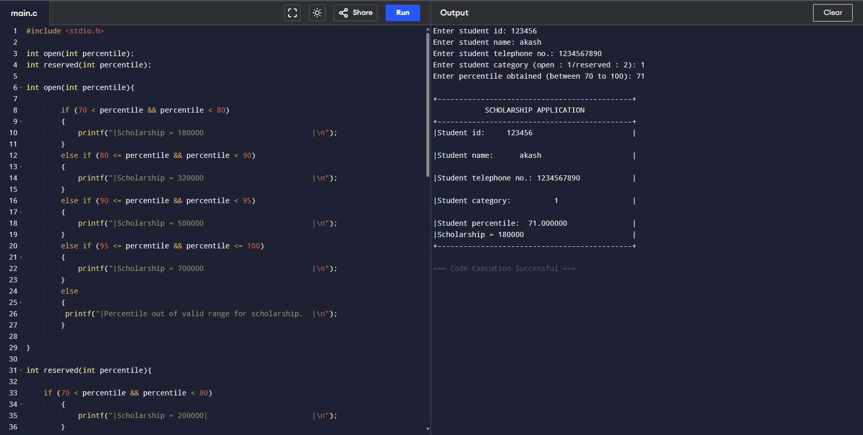

Test Case 2: -
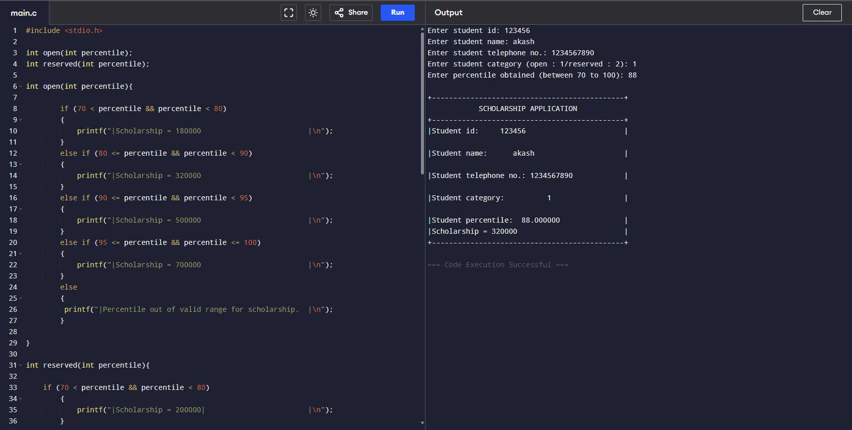

Test Case 3: -
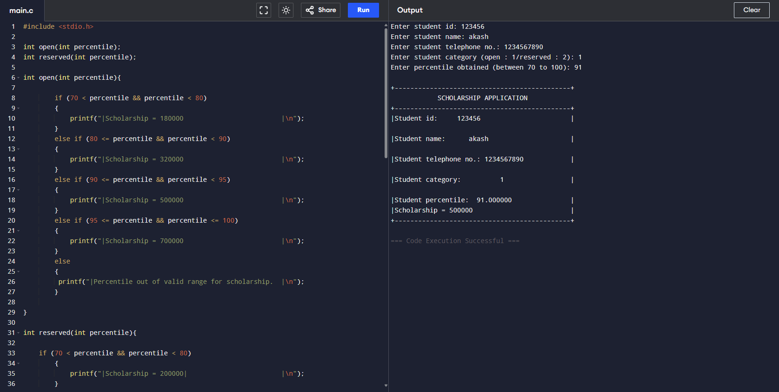

Test Case 4: -
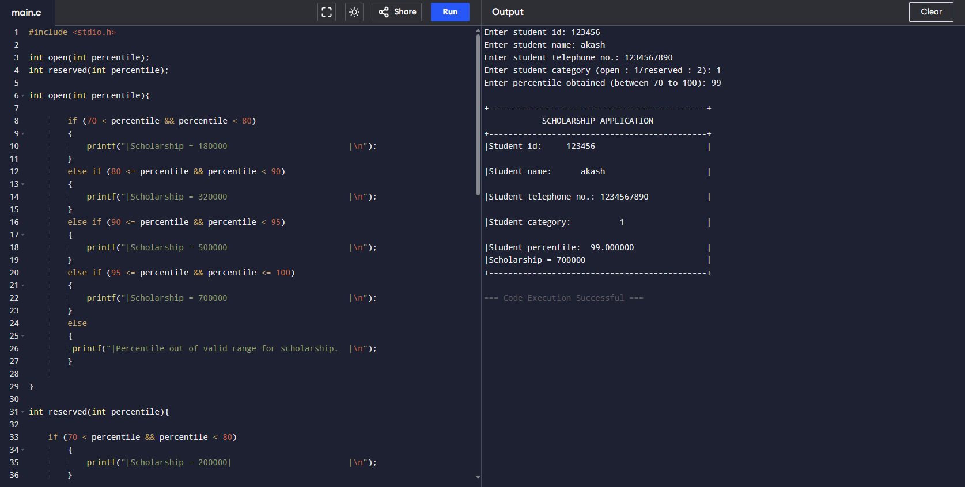

Test Case 5: -
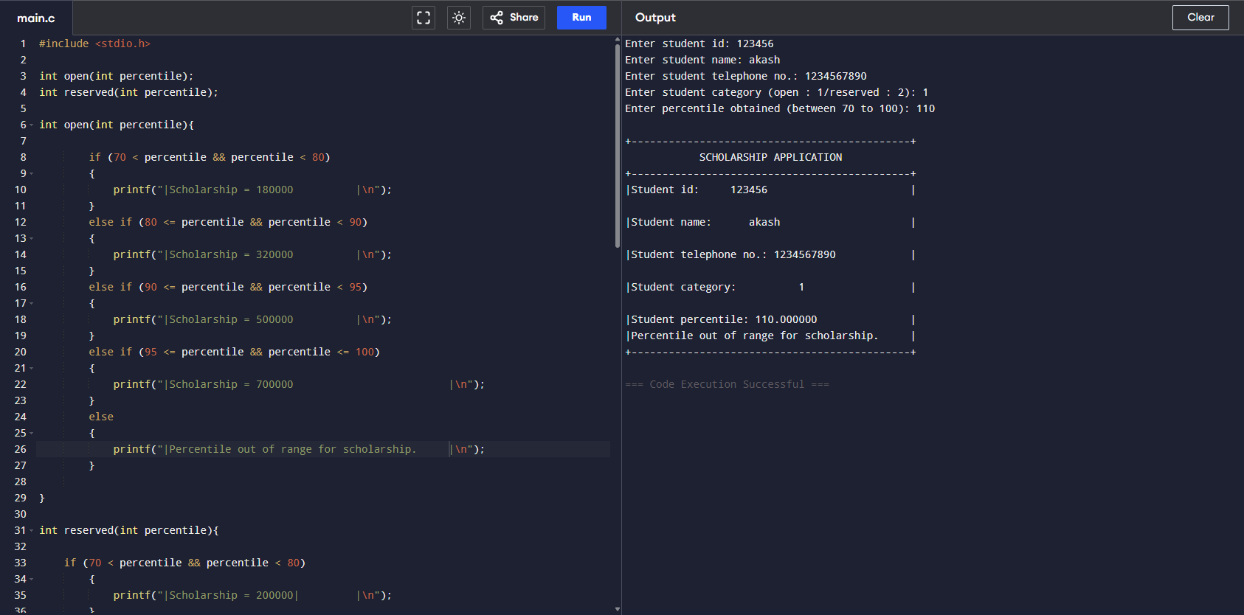

Test Case B: -

Test Case 1: -
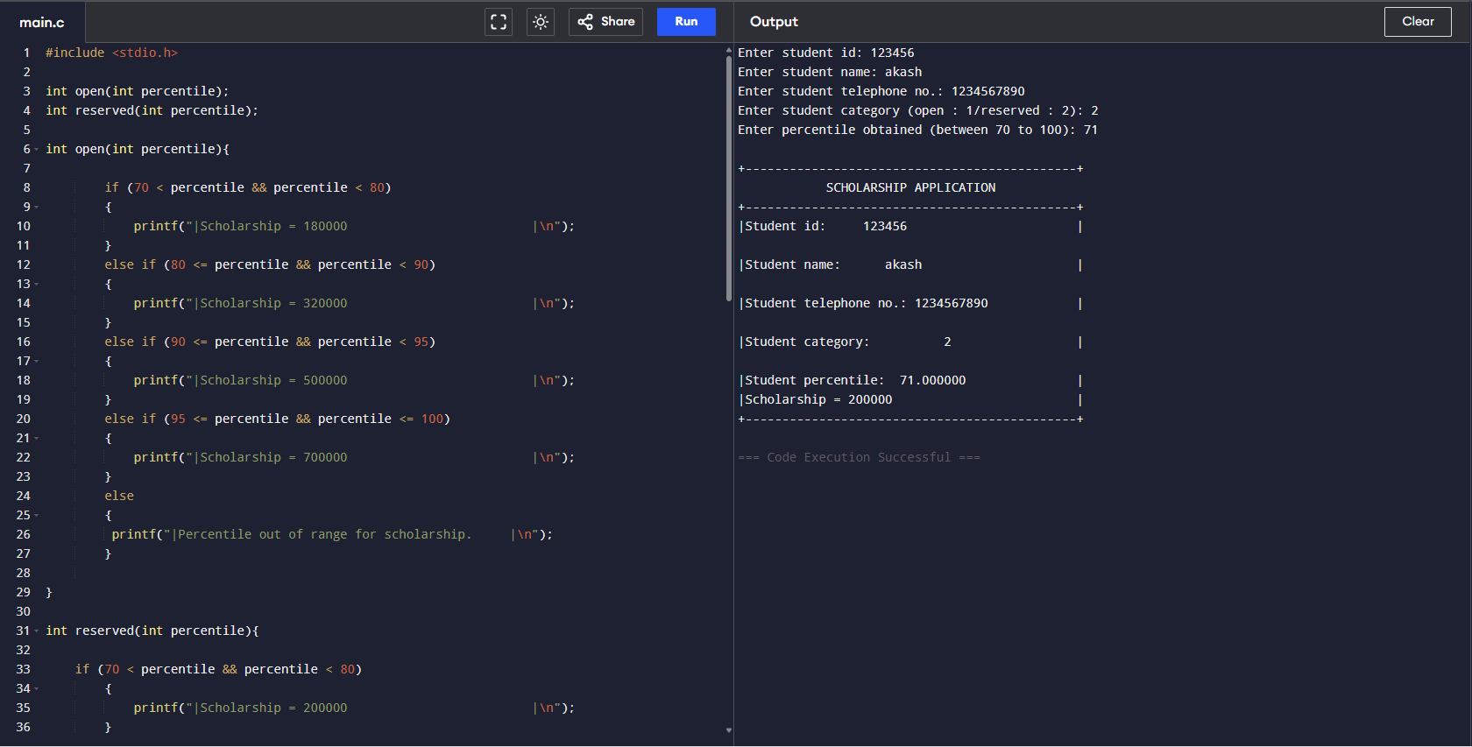

Test Case 2: -
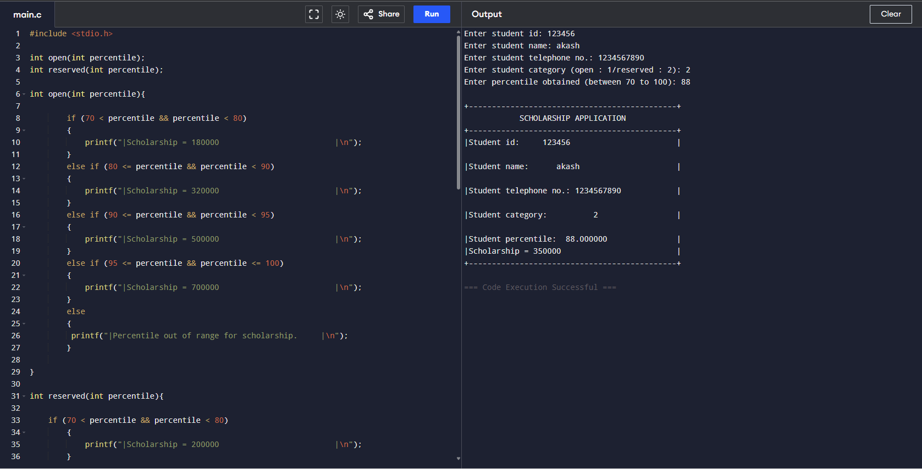

Test Case 3: -
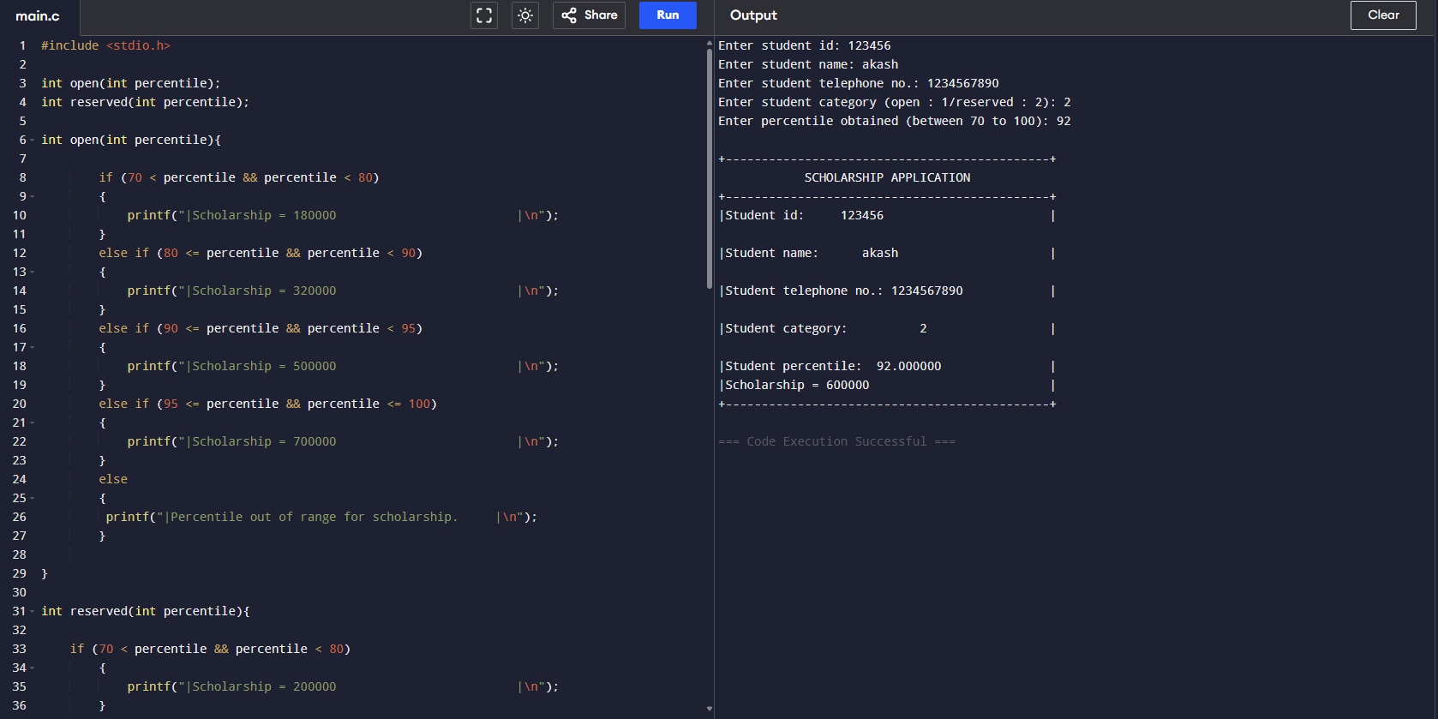

Test Case 4: -
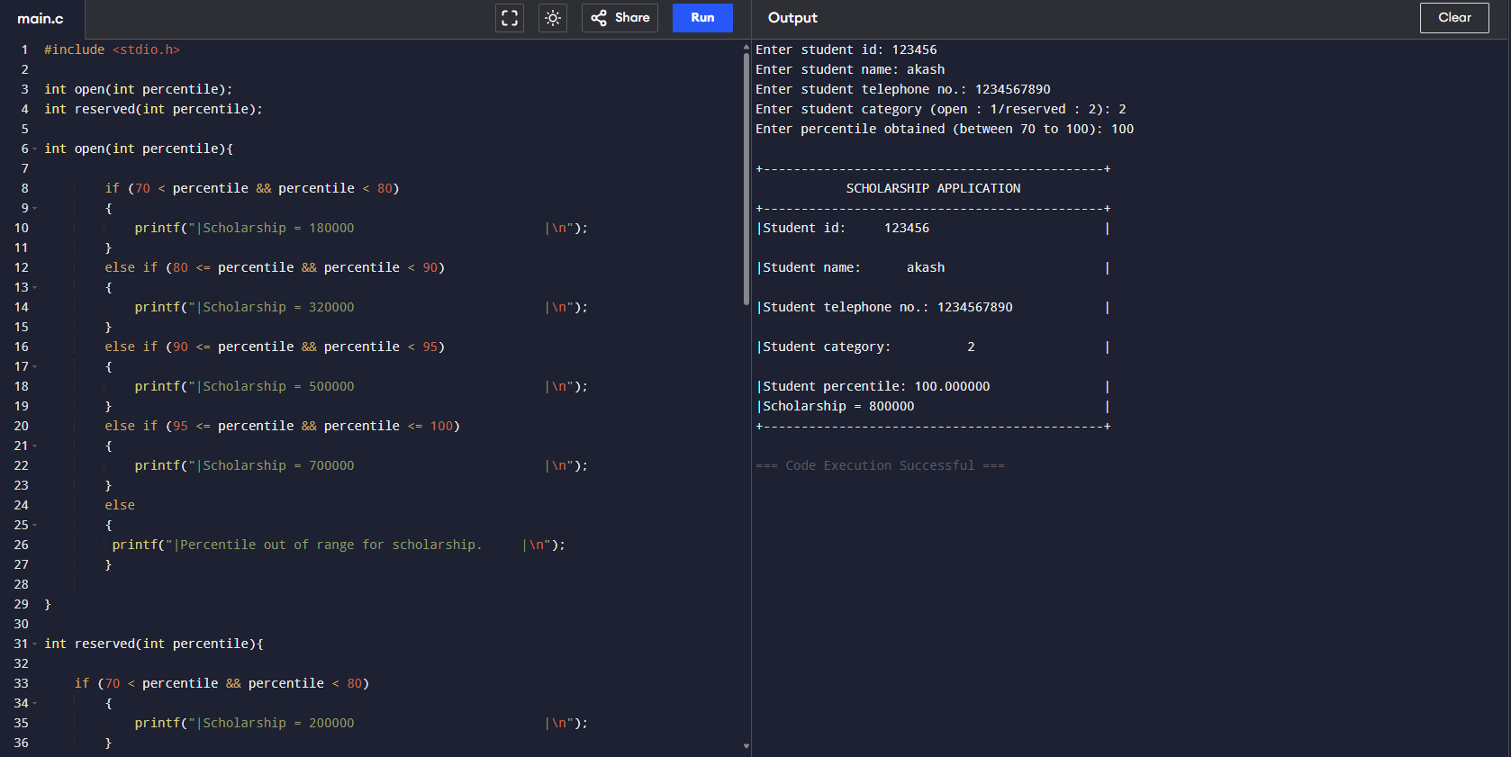

Test Case 5: -
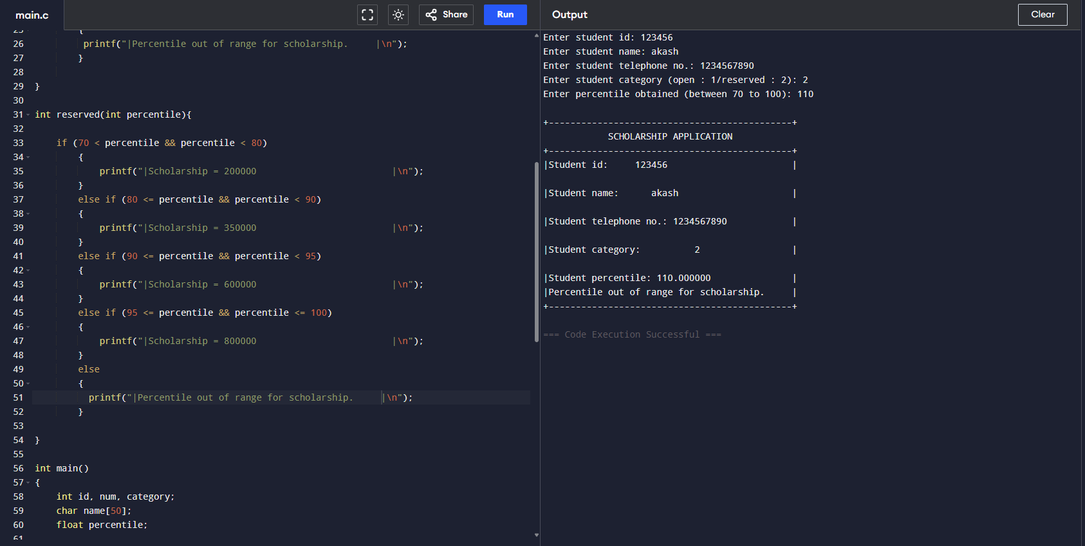

Link: -

https://github.com/Ravin-dev-129/Scholarship_Application

Conclusion: -

Thus, the code is functional as shown by the test cases above and so we have completed our objective.

